HEV model

# 1 subsystem description

Model of the whole car.

# 2 system organization

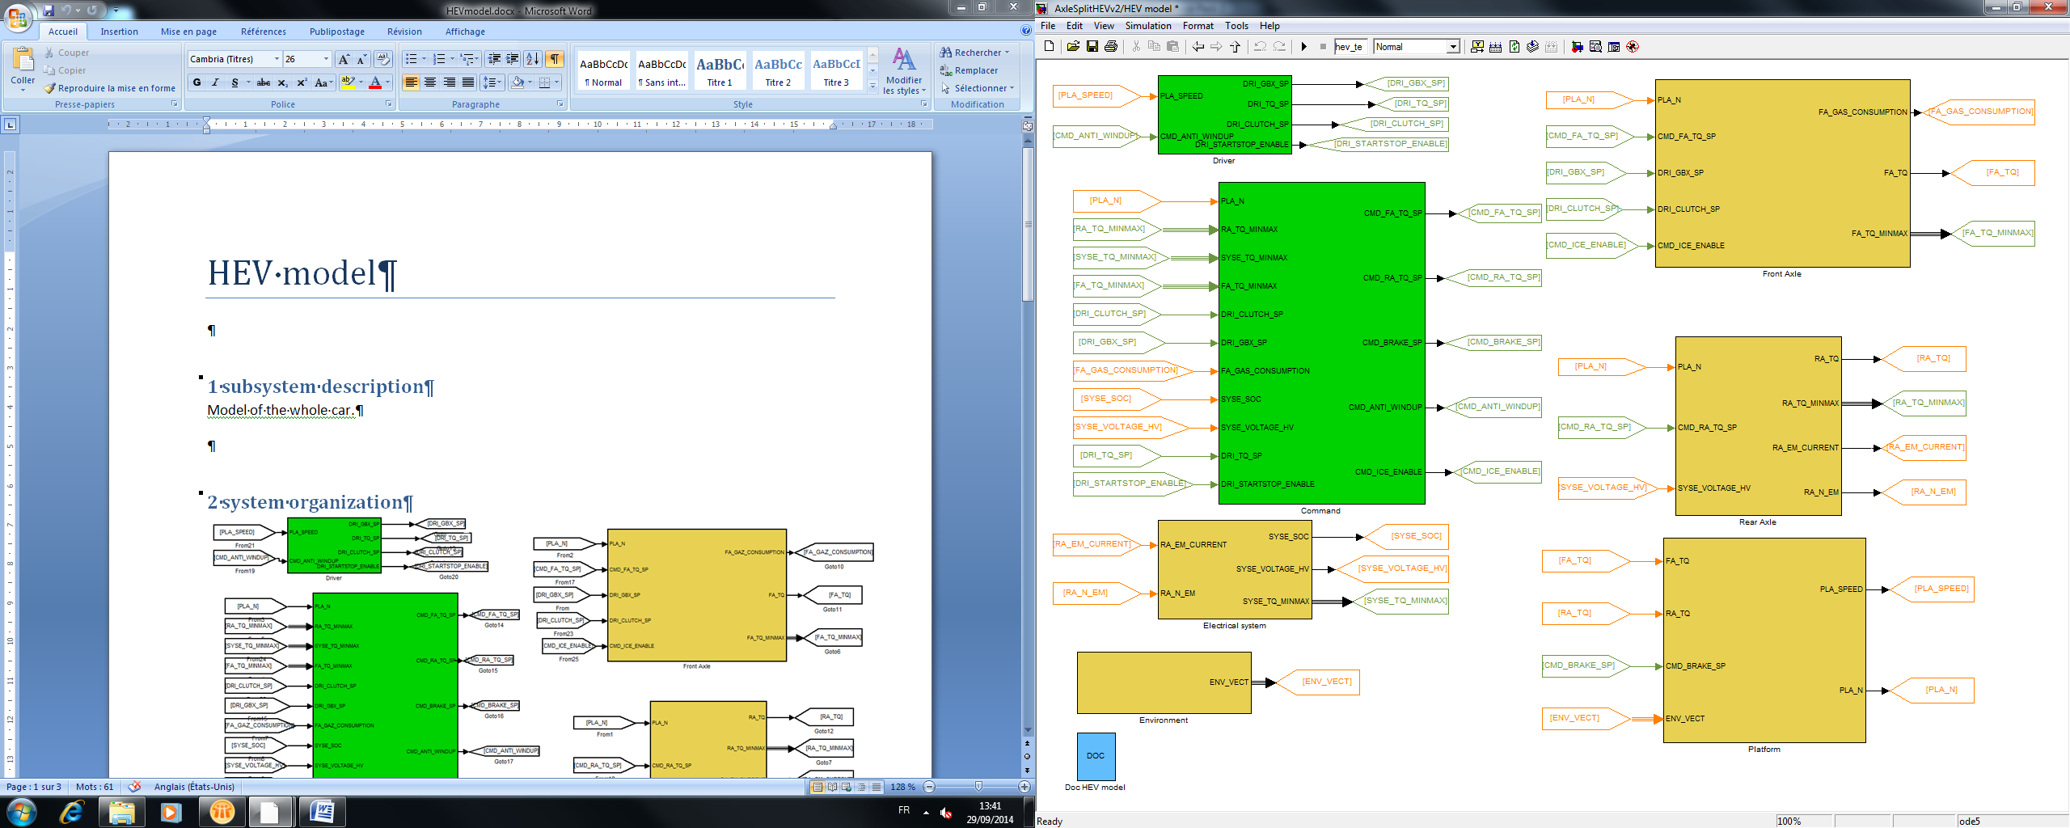

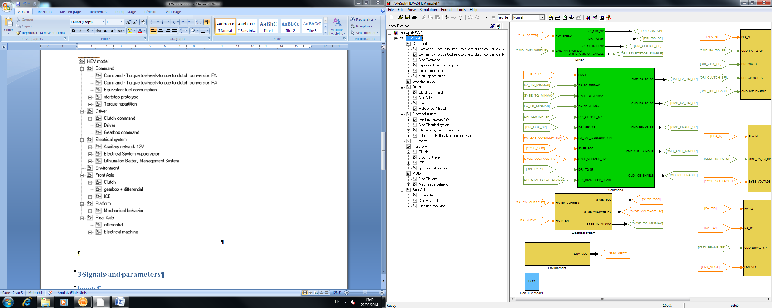

# 3 Signals and parameters

## Inputs

None

## Outputs

None

## Parameters

### Native

|  |  |  |  |  |  |
| --- | --- | --- | --- | --- | --- |
| Name | Type | Unit | Description | Source | Linked to |
| hev_te | Var | s | Time duration of the simulation | User defined (depends of the cycle) | - |

### Inherited

Include all the subsystem

# 4 Notes

* Simulation parameters set as follow:

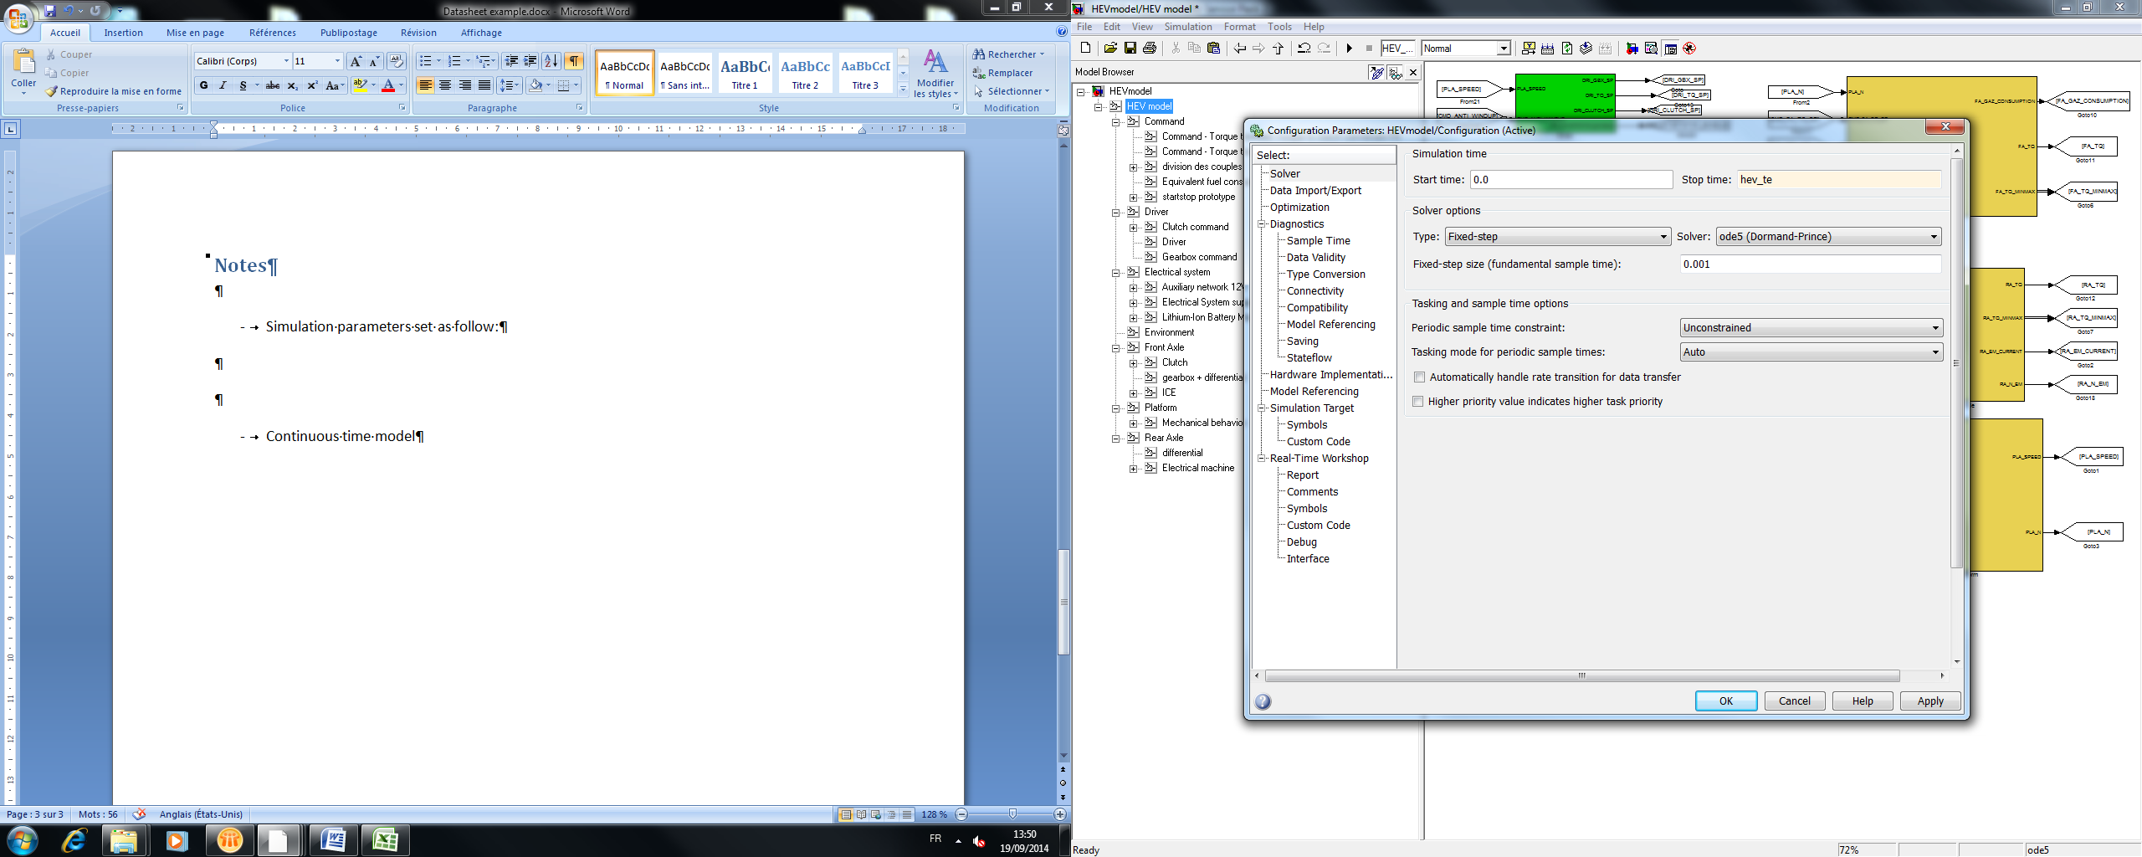

* Continuous time model

# 5 Discrete model

All the continuous transfer function were discretized with the Tustin method on MatLab.

It consists of replacing “s” with: ( is the sample time)

Then we had to check up if the discrete bloc had the same behavior than the previous continuous bloc. The following pictures describe the checking process:

* for the discretization of an integrator:

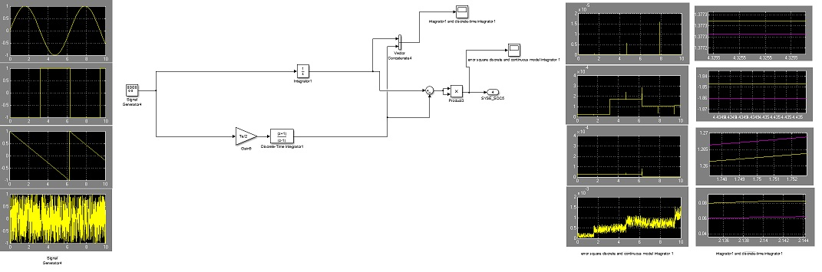

* for the discretization of a special integrator??? Explanations?
* for the discretization of the transfer function 1:

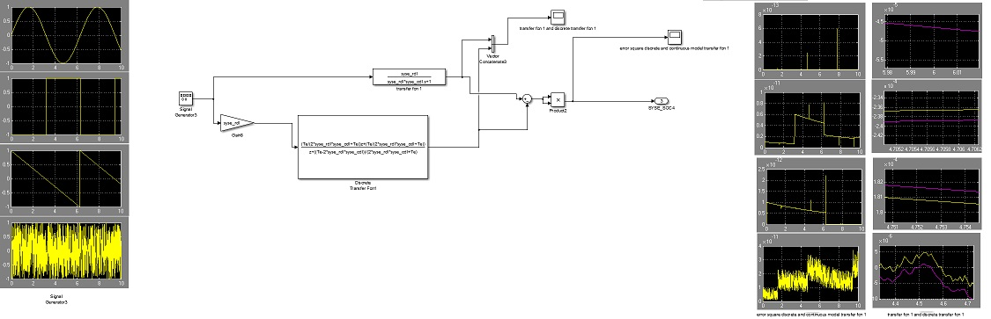

* for the discretization of the transfer function 2:

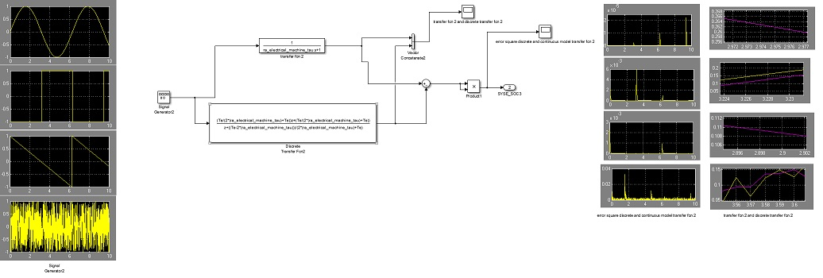

* for the discretization of the transfer function 3:

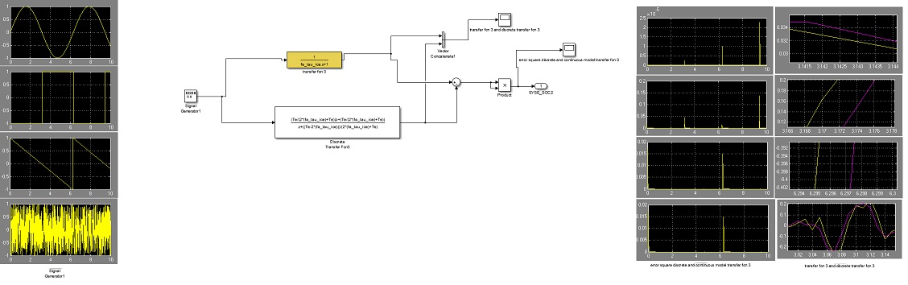

We observe that for every signal sent to the input the error is close to zero. Moreover the gap between the continuous and the discrete signal is very low regardless of the signals.